ASPIES will be a sponsor at this event hosting PhilUP Balloons at our tables. Be sure to stop by, say "hi", and get a balloon creation!
REGISTER HERE:
https://nathanielshope.org/our-programs/make-m-smile/ohio-vips/

Coming soon to Hartville Memorial Park!!!
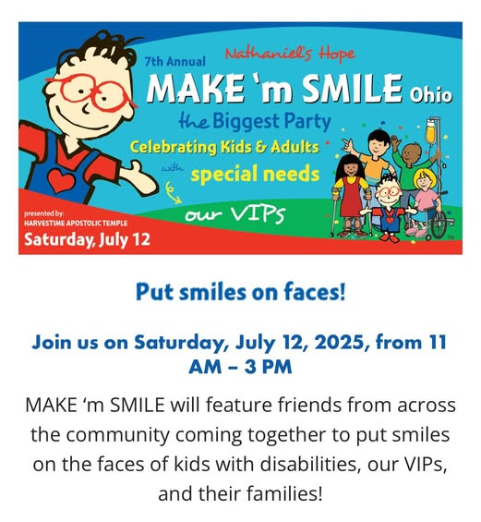
Harvestime Apostolic Temple, Make ‘M Smile Ohio

